**type of operator**

We can use type of operator to execute if else conditions

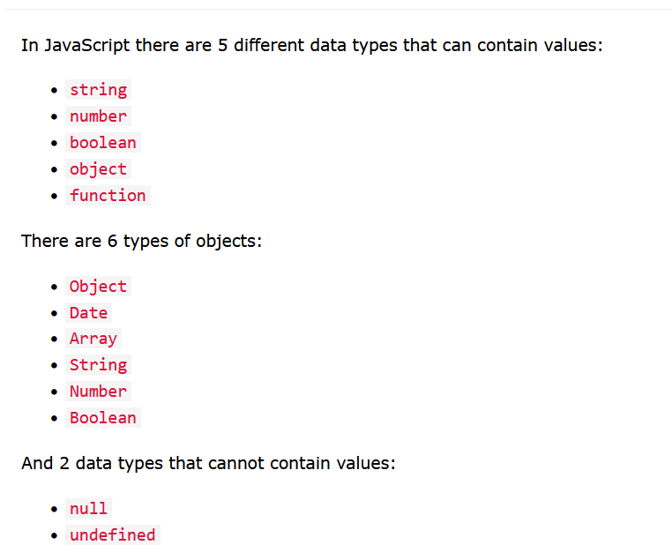

So as long as our data are different data types type of operator is useful

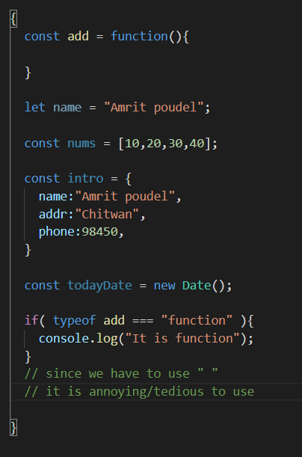

But when we have to check for these

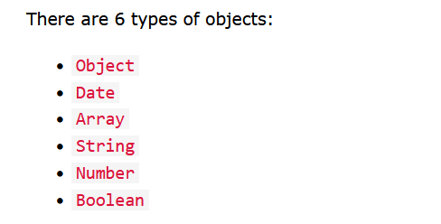

We can not do with type of operator since they are all objects data type

**.constructor**

It is super super useful and handy

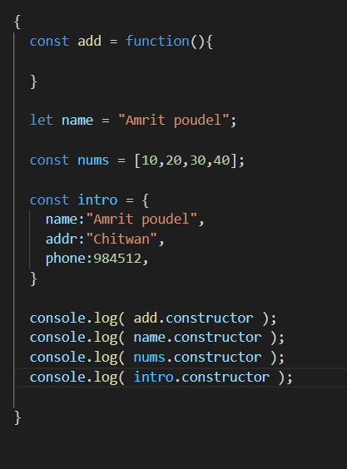

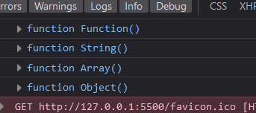

We see that it returns the constructor function

Very useful in if else condition

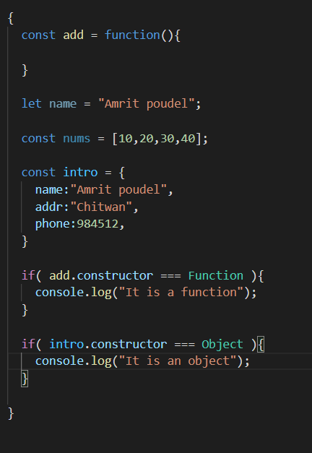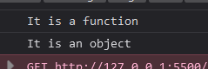

**For array we have Array.isArray( )**

So for arrays better use this or .constructor

